Glue and Sticker Remover 200 ml (P304)

It’s very difficult to remove labels and the glue that attaches it. Ambro-Sol offers a practical solution with this spray; it removes labels and glued parts quickly.
GLUE AND STICKER REMOVER – Solution with a solvent and synthetic polymers. It is quick in dissolving various synthetic adhesives. The label/glue comes off within a few minutes of application.
Caution: may damage plastic surfaces and painted surfaces.
Do not use on fiberglass surfaces.

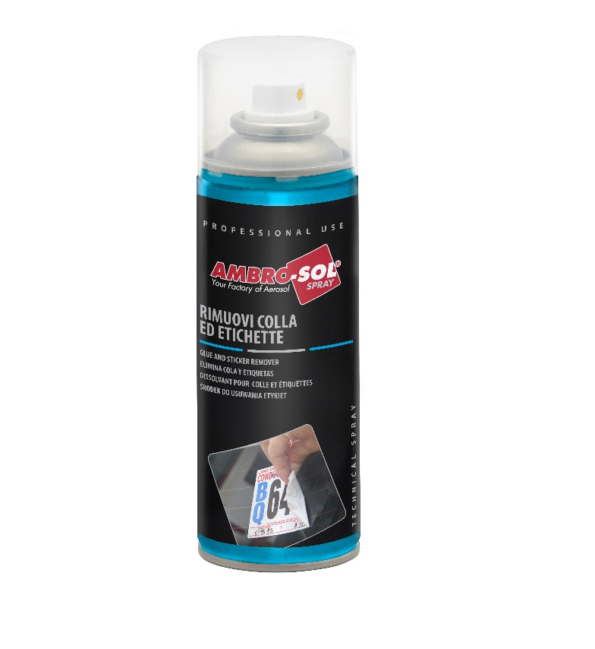

Technical Specifications:
Barcode | EAN: 8034108891484
Quantity | 200 ml
Box / Case | 12 Pz.
Aspect | Tin-Plate can containing under pressure fluid
Color | Whitish
Odour | Characteristic of solvent
Relative density | at 20°C 0,68 ÷ 0,72 g/ml
Flash point | Und .0° C extremely flammable
Pressure at 20°C | 4/6 bar
Water solubility | Insoluble

MODALITY OF STORAGE
Before using: stock the product in a dry location and don’t stock it with a temperature under 5°C and over 40°C, after the use, keep containers closed. In the original package, the product can be conserved for 24 months (warranty). The product doesn’t expire.
After the first usage: conserve in a fresh and dry location, away from hot spring. Keep out of reach of children.
This information, even if reliable, must be considered only approximate. We are not responsible for the wrong use of the product, or the violation of any license. Before using, the users should verify the suitability of the product for its specific use.

HOW TO USE: Shake Well before use. Spray evenly on the part to detach. Leave for a few minutes and remove with a cloth or scrapping tool. In case of incomplete removal of the labels or glue, repeat the treatment.
BEFORE USE, CONSULT THE SAFETY DATA SHEET OF THE PRODUCT.

